Classroom Clash Super Samples

Beat the Clock Challenge
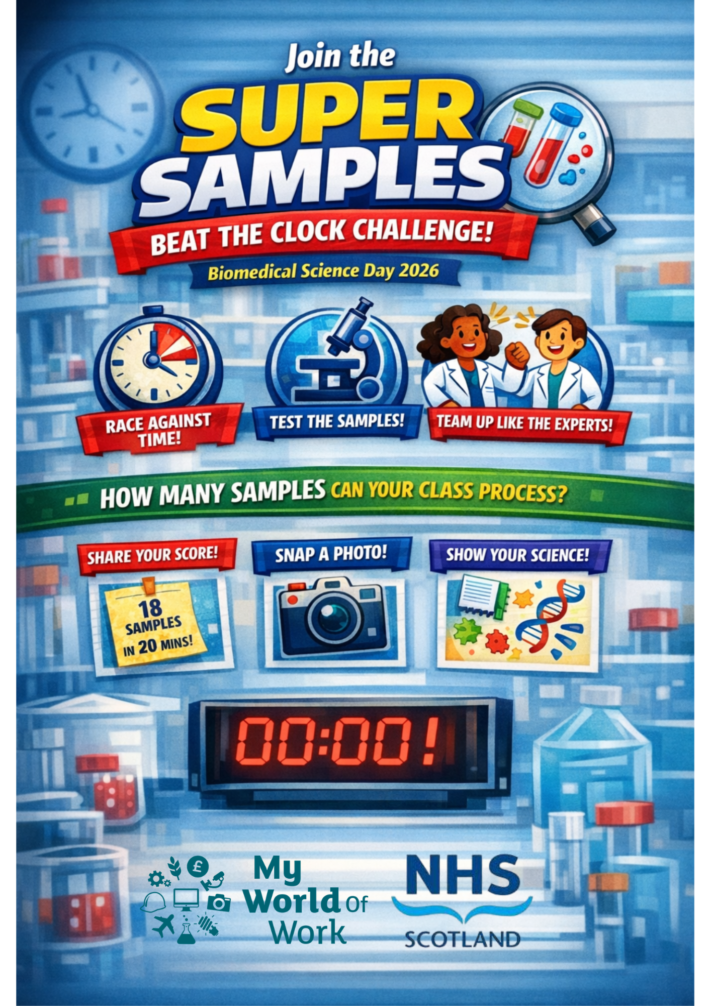

Biomedical Science Day 4th June 2026 – School Take Part Guide
A classroom challenge introducing biomedical science careers
My World of Work and NHS Scotland Careers celebrating Biomedical Science Day on the 4th June. Participation is from Monday 1st June to Friday 5th June 2026.

What is Classroom Clash ‘Super Samples’?
Super Samples is an interactive classroom activity that introduces pupils to biomedical science and NHS laboratory careers by following the journey of patient samples through a hospital laboratory.

What is the Super Samples: Beat the Clock Challenge
For Biomedical Science Day 2026, schools are invited to take part in the Super Samples: Beat the Clock Challenge – a fun, team-based activity where learners work together against time, just like real NHS laboratory using the Super Samples game. Super Samples supports learning for life and work by helping young people see how science can lead to meaningful careers in healthcare.
The focus is on participation, curiosity and teamwork!

How to take part
Work as an NHS laboratory team to test and process as many samples as possible before time runs out.
- Pupils race against the clock, not against other schools
- Success is about:
  - teamwork
  - communication
  - problem-solving
- Every class that takes part is recognised – there is no pass or fail
This reflects how biomedical scientists work every day to deliver timely, accurate results that support patient care.

What Schools Need to Do
Taking part is simple and flexible.
- Run the Super Samples / Classroom Clash activity
Use the ready-made lesson plan and game resources (see the links and QR codes)
- Set a time limit
For example, one lesson take-over to try out as many attempts or a set countdown on the number of attempts.
- Work in teams
Pupils take on biomedical scientist roles, make decisions and process samples as efficiently as possible – add their scores to the classroom board table.
- Take part in one of the mock lab experiments from the lesson plan (optional)

How to Share Your Participation
Schools can choose one or more ways to share their involvement:
- ✅ Share your team score
“Our class processed 18 samples in 30 minutes.”
- ✅ Share a photo
  - Teams working together
  - Lab boards, mock lab experiment resources, teamwork in action
  - No pupils need to be identifiable
- ✅ Share a reflection
  - One thing pupils learned about biomedical science
  - One teamwork skill they used to beat the clock for the challenge

Social Media updates for your challenge
Schools can share on school approved social channels, or via the suggested campaign hashtags and tag in the Healthcare Science PSD Scotland page on Facebook or Instagram , My World of Work and Institute of Biomedical Science #BiomedicalScienceDay2026, #AtTheHeartOfHealthcare

How Participation is Recognised
All participating schools will receive:
- 🧪 A digital participation certificate
Biomedical Science Day 2026 – Super Samples Challenge (send your photos to hcs@nes.scot.nhs.uk and receive your certificate)
- 🧪 Celebration and shout-outs
Selected schools may be featured on NHS Scotland Careers or Biomedical Science Day posts
- 🧪 Opportunities to connect to careers
Links to real NHS biomedical science roles and pathways
There are no winners or losers – the focus is on curiosity, teamwork and learning together.
Why Take Part?
✔ Ready-to-use classroom activity
✔ Links science learning to real NHS careers
✔ Builds teamwork and communication skills
✔ Celebrates Biomedical Science Day in a meaningful way

Careers connection
Biomedical scientists play a vital role in NHS Scotland, supporting diagnosis, treatment and public health. There are clear pathways into biomedical science careers through school subjects, further and higher education, and workplace learning. See the QR Links below

Explore further to take part for your classroom
Scan the QR codes below to explore resources and careers information.
Classroom Clash ‘Super Samples’ Game  Classroom Clash - Skills Development Scotland" | Classroom Super Samples lesson Plan  2000_classroom-clash-online-teacher-resources-super-samples.pdf
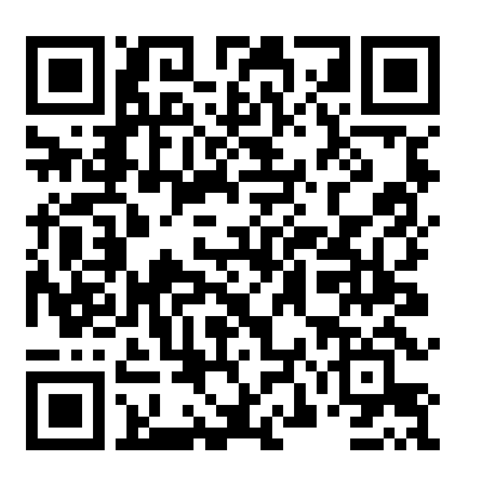 | 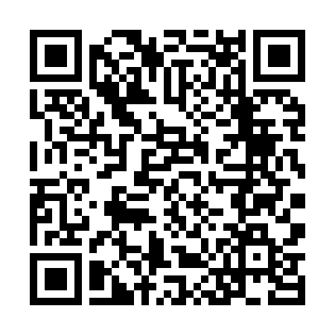
My world of Work – Biomedical Scientist career role  https://www.myworldofwork.co.uk/search-job-profiles/job-profiles/biomedical-scientist | Biomedical Scientist careers (NHS Scotland)  Biomedical scientist | NHSScotland Careers
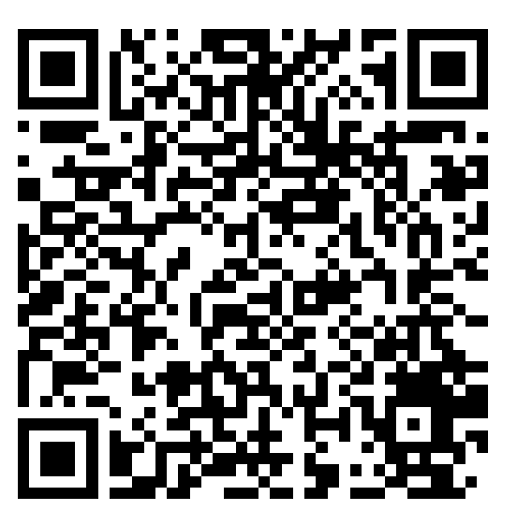 | 